Chapter 5, Problem 84

A four-bit R-2R ladder DAC is presented in Fig. 5.103.

- Show that the output voltage is given by

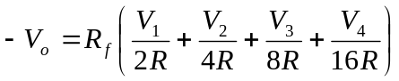

- If R_{f} = 12 kΩ and R = 10 kΩ, find |V_{o}| for [V₁V₂V₃V₄] = [1011] and [V₁V₂V₃V₄] =
[0101].

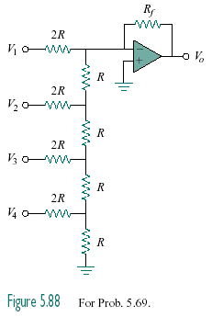
Figure 5.103
For Prob. 5.84.

